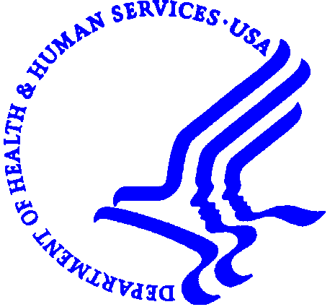

FAMILY-TO-FAMILY HEALTH CARE INFORMATION AND EDUCATION CENTERS

FACT SHEET

F2FHIC Grantees

There are currently 35 Family-to-Family Health Care Information and Education Centers (F2FHIC) grantees, one in each state – 29 funded by the Centers for Medicare and Medicaid Services (CMS) and 6 funded by Health Resources and Services Administration (HRSA). HRSA will award additional grants this spring. The recently enacted provisions of the Deficit Reduction Act also provide for an additional $12 million over a three-year period for HRSA to support Family to Family Health Information and Education Centers in all States and the District of Columbia. Grants range in amount from $50,000 to $105,000 per year for 3-4 years.

Purpose
The purpose of these grants is to support the development of comprehensive health information centers providing families of Children and Youth with Special Health Care Needs (CYSHCN) with information about health care and health care financing. Non-profit organizations were awarded grants to establish statewide family-run centers.

Activities
Family-to-Family Health Care Information and Education Centers:
Provide information, and education on health care and support to families with children with special health care needs, parent groups, providers, and other stakeholders;
Provide information and referral to other programs and benefits that can help children remain in the community (i.e., respite, home health, transportation services, income support, and health promotion programs);
Collaborate with existing Family-to-Family Health Care Information and Education Centers to benefit children with special health care needs;
Provide a forum for peer group discussion and interaction;
Help families assess their potential eligibility for public long-term care programs and benefits; and
Promote the philosophy of individual and family-directed supports and family centered medical care.

Techniques
- Resource and material development: Websites, listserv, newsletters, brochures, fact sheets
- Toll free lines offering one-on-one counseling
- Peer to peer support activities
- Education Initiatives: in-person, web-based, video, conference calls
  - Access to services, Understanding the appeals process, Understanding Medicaid, Self-directed services, Medicaid Home and Community Based Waiver Programs, Working within the insurance system, Understanding what is covered by insurance, Transitioning to Adulthood
  - Provided for parents and professionals
- Supporting parents as they participate in policymaking
- Informing policymakers
- Developing partnerships

