Aging and Disability Resource Centers

A Joint Program of the Administration on Aging and Centers for Medicare & Medicaid Services - Overview

Fact Sheet Title

Fact Sheet Sub Title
U.S. Department of Health and Human Services
Administration on Aging
F
A
C
T

S
H
E
E
T

BACKGROUND

The Aging and Disability Resource Center Program (ADRC) is a collaborative effort of the Administration on Aging (AoA) and the Centers for Medicare & Medicaid Services (CMS) designed to streamline access to long-term care.

The ADRC initiative supports state efforts to develop “one-stop shop” programs at the community level that will help people make informed decisions about their service and support options and serve as the entry point to the long-term support system. States are using ADRC funds to better coordinate and/or redesign their existing systems of information, assistance and access and are doing so by forming strong state and local partnerships.

Resource Center programs provide information and assistance to individuals needing either public or private resources, professionals seeking assistance on behalf of their clients, and individuals planning for their future long-term care needs. Resource Center programs also serve as the entry point to publicly administered long term supports including those funded under Medicaid, the Older Americans Act and state revenue programs.

ADRC grantee states target Resource Center services to the elderly and at least one additional population of people with disabilities (i.e., individuals with physical disabilities, serious mental illness, and/or mental retardation/developmental disabilities). ADRCs are working towards the goal of serving all individuals with long-term care needs regardless of their age or disability.

AOA & CMS VISION FOR RESOURCE CENTERS

The goal of the ADRC Program is to empower individuals to make informed choices and to streamline access to long-term support. Long-term support refers to a wide range of in-home, community-based, and institutional services and programs that are designed to help individuals with disabilities.

The vision is to have Resource Centers in every community serving as highly visible and
trusted places where people can turn for information on the full range of long term support options.

In many communities, long-term support services are administered by multiple agencies and have complex, fragmented, and often duplicative intake, assessment, and eligibility functions. Figuring out how to obtain services is difficult. A single, coordinated system of information and access for all persons seeking long term support minimizes confusion, enhances individual choice and supports informed decision-making. It also improves the ability of state and local governments to manage resources and to monitor program quality through centralized data collection and evaluation.

ADRC GRANTEES

AoA and CMS launched the ADRC initiative in the fall of 2003 through the funding of 12 grants to states to develop pilot programs. Additional grants were awarded in 2004 and 2005 bringing the total number of states funded through the ADRC initiative to 43.

While grantees are only required to pilot their ADRC in at least one community, they are all striving to replicate the program across the entire state. The map on the reverse side of the Fact Sheet indicates states that have been awarded ADRC grants and the year they received their award.

TECHNICAL ASSISTANCE

To support ADRC grant projects, AoA and CMS are each funding technical assistance providers. The AoA funded ADRC Technical Assistance Exchange (TAE) coordinates technical assistance efforts and collaborates closely with the CMS funded Community Living Exchange Collaborative. Technical assistance is provided through individual assistance to grantees, national meetings, monthly teleconferences, a weekly newsletter, the ADRC-TAE website and in other ways. Many of the technical assistance products developed for grantees are available to the public on the website.

ADDITIONAL INFORMATION

For additional information on the ADRC initiative, please visit The ADRC Technical Assistance Exchange website at www.adrc-tae.org. The website includes contact information for AoA and CMS ADRC project officers, summary information on each of the grantees, and a variety of resources related to this initiative.

You can also find additional ADRC information on the AoA website at http://www.aoa.gov/prof/aging_dis/aging_dis.asp or the CMS web site at http://www.cms.hhs.gov/newfreedom.

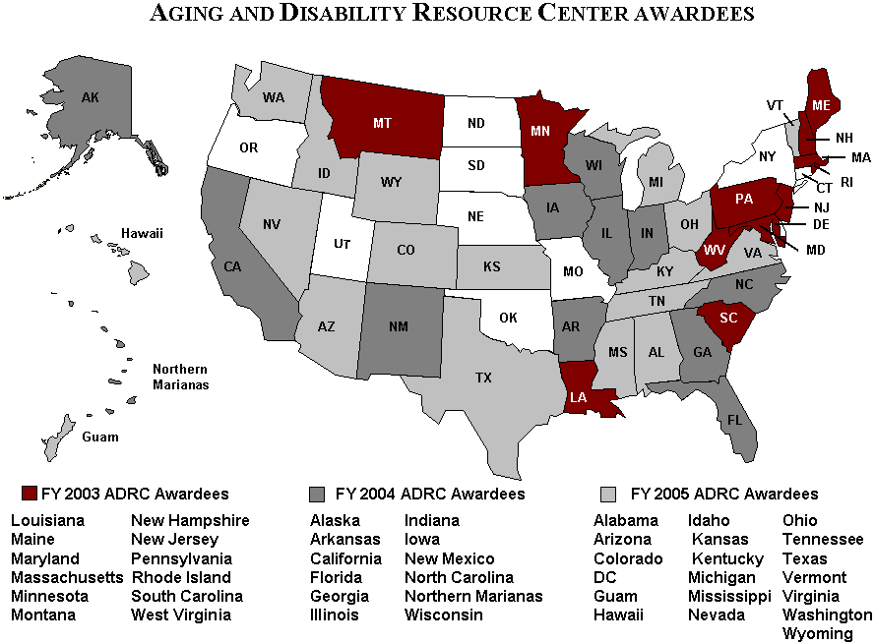
AoA recognizes the importance of making information readily available to consumers, professionals, researchers, and students. Our website provides information for and about older persons, their families, and professionals involved in aging programs and services. For more information about AoA, please contact: US Dept of Health and Human Services,
Administration on Aging, Washington, DC 20201; phone: (202) 401-4541; fax (202) 357-3560; Email: aoainfo@aoa.gov; or contact our website at: www.aoa.gov
FOR MORE INFORMATION

