March 2005
Newsletter #3

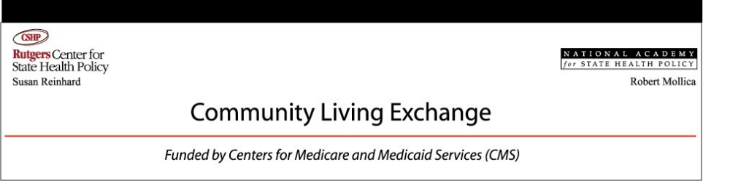

Articles:
Physicians’ Role in Determining Level of Care
Page 2

Nurse Practice Policies for Home and Community Living
Page 3

ADRC Toolbox
Page 4

Massachusetts Connecting the Dots
Page 5

Making Medicaid Work in the 21st Century
Page 6

Assessment Instruments
Page 7

HCBS Quality Management Roles & Responsibilities
Page 9

CMS New Freedom Initiative Conference
Page 8

Family Caregiving
Page 10

Housing
Page 11

Greetings from the Exchange at CSHP!
Greetings from the Rutgers CSHP/NASHP Community Living Exchange. This is the third in a series of newsletters we are producing here at the Exchange to provide assistance to our CMS Real Systems Change grantees. This newsletter is produced biannually. If you have any comments, please respond to the following email address: abemis@ifh.rutgers.edu.
Using the Minimum Data Set (MDS) to Facilitate Nursing Home Transition

On February 18, 2005, the Centers for Medicare & Medicaid Services (CMS) issued a State Medicaid Directors letter that provides guidance on the procedure around the release of Long-Term Care Minimum Data Set (LTC/MDS) information. In that letter, CMS referenced our recent Issue Brief, Using the Minimum Data Set (MDS) to Facilitate Nursing Home Transition, by Susan Reinhard, Leslie Hendrickson and Ann Bemis.
Consumer advocates and state leaders have been exploring ways to identify nursing home residents who want to return to their homes and communities. One effort involves the potential use of the LTC/MDS, particularly Section Q, which addresses residents’ discharge preference. Our technical assistance document provides practical information about how state agencies can use these federal data on nursing home residents to improve nursing home transition efforts.
In an effort to assist states in Americans with Disabilities Act (ADA) compliance activities, CMS is allowing State Medicaid Agencies or designated entities to access LTC/MDS data on the residents and Medicaid beneficiaries of that state, after it receives and approves a Medicaid Data Use Agreement (MDUA) from the state. The MDUA, which binds parties to the requirements of the Privacy Act and the applicable LTC/MDS System of Records, must be signed by the requestor and the custodian of the data. CMS believes that the LTC/MDS information will help states and designated entities identify residents with disabilities who have a desire to live in the community, and will provide information related to the level of services necessary to fulfill states’ ADA requirements in relation to these individuals.
Our report provides information on the LTC/MDS, including website links to federal forms and discussions of LTC/MDS-related topics. It describes two Data Use Agreements used by state agencies and CMS. It also recommends that agencies of the state Medicaid program use the ten-year Medicaid DUA, and it discusses examples of how MDS data are used in nursing home transition projects.
Contact: Susan Reinhard at sreinhard@ifh.rutgers.edu or 732-932-3105.
- Using the Minimum Data Set (MDS) to Facilitate Nursing Home Transition, http://www.hcbs.org/moreInfo.php/nb/doc/1137
- CMS letter to State Medicaid Directors: Release of LTC/MDS Data, http://www.hcbs.org/moreInfo.php/nb/doc/1138

The LTC/MDS
data will help states and their partners to identify residents with disabilities who want to live in the community.
Community Living Exchange
Page 2

Determining Level of Care: Must Physicians
Have a Role in the Process?
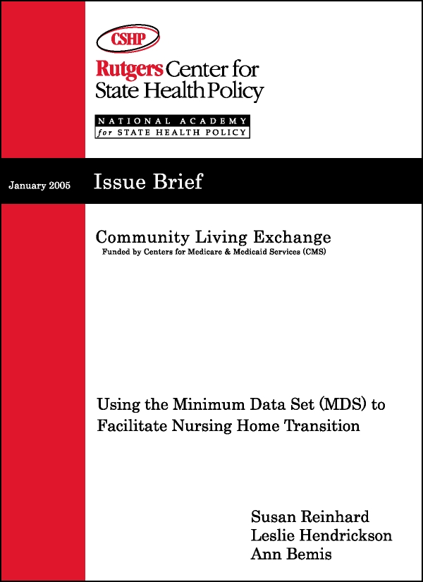

States that are trying to streamline policies and paperwork to help people receive long-term care and support in community settings are re-examining the processes they use to determine eligibility for these programs. Robert Mollica (National Academy for State Health Policy) and Susan Reinhard (Rutgers Center for State Health Policy) have written a technical assistance document that focuses on one of those processes, determining level of care. Home and community-based services (HCBS) waiver rules require that states describe the procedures that they use to assess level of care. States must also describe the qualifications of individuals performing the waiver assessment, which must be as high as those of individuals assessing the need for nursing facility (NF) care. The assessment instrument for this application must be the same as any assessment instrument used to establish level of care of prospective nursing facility residents. However, the regulations do not specify how the assessment should be done, what it needs to include, who should complete it or the criteria that must be used. Those decisions are made by each state and described in the waiver application.
The nursing facility regulations do require that a physician personally approve in writing a recommendation that an individual be admitted to a facility. Each resident must remain under the care of a physician. However, because the level of care determination occurs before the requirements for long-term care facilities apply, states do not have to obtain a physician’s approval of the level of care for admission to a nursing home or to qualify for HCBS. States may have required physician approval prior to the expansion of HCBS programs, single entry points and pre-admission screening. These mechanisms now offer policy makers an alternative to what is normally a time consuming process that can delay access to waiver services.
Contact Robert Mollica at rmollica@nashp.org or 207-874-6524.
- Determining Level of Care: Must Physicians Have a Role in the Process? http://www.hcbs.org/moreInfo.php/nb/doc/1176/

Community Living Exchange
Nurse Practice Policies for Home and
Community Living

Page 3

A critical policy issue confronting states that are trying to promote consumer direction is the extent to which unlicensed workers can assist consumers in their long-term care and support activities. State policy varies considerably, particularly in the area of nurse practice acts. Susan Reinhard is leading a team at the Community Living Exchange that is producing a series of reports examining how states are addressing the issue of nursing practice from a legislative and regulatory perspective, so that consumers are better able to exercise their preferences to live in their own communities.
In the most detailed analysis conducted to date of both nurse practice acts and regulations in relation to consumer-directed care, the report titled Consumer Directed-Care and Nurse Practice Acts found that state-mandated nurse practice regulations have a significant influence on the growth of consumer-directed home and community-based care. Susan Reinhard observed that most states have language in either the Nurse Practice Act (NPA), the implementing regulations, or both, to make it possible for nurses to legally delegate to others.
The Community Living Exchange continued research in this area in two subsequent reports, Consumer-Directed Care and States’ Nurse Practice Policies (January 2004), and most recently Oregon’s Nurse Practice Policies for Home and Community Living (December 2004). Oregon made reform of the Nurse Practice Act and regulations a core part of its strategy to promote home and community-based care. In an effort that spans a quarter century, Oregon state policy makers from its State Board of Nursing and the Oregon Department of Human Services have worked together to synchronize policies to better serve people of all ages with disabilities who live in the community. Since 1987, Oregon has continued to make amendments to its Nurse Practice Act that permit nurses to delegate tasks to unlicensed workers that formerly were performed only by nurses. According to the Nurse Practice Act and implementing regulations, nurses who follow the regulations are not subject to action for civil damages for the performance of the worker, unless the worker is acting upon the nurse’s specific instructions, or no instructions were given when they should have been provided. The nurse retains the responsibility for determining when it is appropriate to teach or delegate nursing tasks to workers. Delegation rules apply only to settings where a registered nurse is not regularly scheduled and not available to provide direct supervision.
The Community Living Exchange is conducting a number of activities to provide additional insight into issues around Nurse Delegation, including:
- Several studies on individual state activities in Nurse Delegation will be published in our State Policy in Practice report series over the next few months, beginning with the state of Washington.
- A summit on Nurses Collaborating with Consumers to Promote Community Living in Washington, DC, is leading to the development of guiding principles that will be disseminated broadly to the nursing community, consumers and state policy makers.
- A summit held in Arkansas in August 2004 and subsequent technical assistance helped state policy makers and consumers agree on a new Consumer-Directed Care bill. Attention now moves to the development of regulations by the State Board of Nursing.
Contact: Susan Reinhard at sreinhard@ifh.rutgers.edu or 732-932-3105.
- Consumer-Directed Care and States’ Nurse Practice Policies, http://www.hcbs.org/moreInfo.php/nb/doc/448/
- Oregon’s Nurse Practice Policies for Home and Community Living, http://www.hcbs.org/moreInfo.php/nb/doc/1142/
- Consumer-Directed Care and Nurse Practice Acts, www.cshp.rutgers.edu

Oregon’s Nurse Practice Act permits nurses to delegate tasks to unlicensed workers that formerly were performed only by nurses.

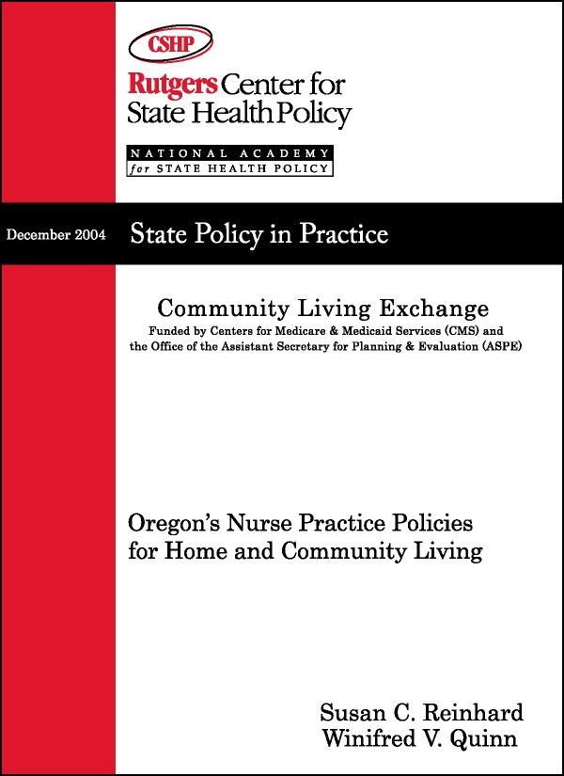

“This bill in
Arkansas should clear the way for more consumer direction and for more families to participate in respite care for their children…”
Comment from an Arkansas stakeholder
Community Living Exchange

Aging and Disability Resource Center Toolbox

The Aging and Disability Resource Center (ADRC) Grant Program, a cooperative effort of the Administration on Aging (AoA) and the Centers for Medicare & Medicaid Services (CMS), was developed to assist states in their efforts to create a coordinated system of information and access for all persons seeking long-term support. The Resource Centers were instituted to minimize confusion, enhance individual choice, support informed decision-making, and increase the cost effectiveness of long-term support systems. The long-range goal is to have Resource Centers in every community, serving as highly visible and trusted places where people can turn for information on the full range of long-term support options. The Resource Centers are also intended to improve the ability of state and local governments to manage resources and to monitor program quality through centralized data collection and evaluation. Additional information on the grant program can be found at the ADRC Technical Assistance Exchange at: www.adrc-tae.org.
Rutgers CSHP/NASHP Community Living Exchange created an ADRC Toolbox so that ADRC grantees had a succinct explanation of the AoA-CMS requirements for each topic and to provide materials to support the design, development and operation of Resource Centers. The newly revised ADRC Toolbox Version 4 is an expanded report that includes over 250 resources to assist states in streamlining access to home and community-based services.
To obtain a copy of the ADRC Toolbox Version 4 on a CD-ROM, contact Jennifer Gillespie at: (207) 874-6525 or jgillespie@nashp.org.

Currently there
are 24 states developing Resource Center models through state grants of up to $800,000 issued for a three-year period.
Page 4

Community Living Exchange
Page 5
Massachusetts Connecting the Dots

In December, 2004, the Rutgers Center for State Health Policy (CSHP) and the National Academy for State Health Policy (NASHP) organized and facilitated a Connecting the Dots meeting for the Massachusetts Executive Office of Health and Human Services (EOHHS) Office of Disabilities and Community Services and the state’s ten New Freedom Initiative grantees. Connecting the Dots is a technical assistance activity of the Rutgers CSHP/NASHP Community Living Exchange to facilitate coordination in states with multiple grants from the Centers for Medicare & Medicaid Services (CMS). The main purpose of this meeting was to promote sustainability of promising CMS-funded infrastructure developments by explicitly linking them to the state’s strategic plan.
The meeting brought together key policy makers, consumers, and project staff to discuss linkages between Systems Change grant activities and the EOHHS strategic plan, Forging the Future (www.dma-chpr.org/SystemsChange). It provided the opportunity for state officials, grant staff and stakeholders to learn more about the EOHHS strategic plan, which was developed to reorganize and align policy, financing and planning in long-term supports, mental health, and employment for people with disabilities. The meeting stimulated productive dialogue among stakeholders, and through these discussions attendees came to the agreement that the state’s strategic plan is the key to sustainability of ongoing HCBS initiatives. The strategic plan contains six goals and principles that address: Wellbeing; Individual and Family Independence; Programs and Services Supporting Independence; Coherent, Coordinated and Accessible Programs; Maximizing Limited Resources; Incorporation of Quality Improvement and Organizational Learning.
Sustainability was a key topic of discussion, and is also an area in which the Rutgers CSHP/NASHP Community Living Exchange is conducting extensive research with current CMS grantees. Through interactions in small break-out groups, attendees at this conference on Massachusetts programs identified several factors that are critical to obtaining continued support for these activities. Grantees recognized a key requirement for sustainability as being the ability to provide concrete evidence of the progress made through grants. Grantees identified the following requirements for achieving this goal: measurable factors that illustrate the impact of the projects; tools and processes for collecting and analyzing data; and, communication mechanisms for sharing the results with the administration and legislature. Continued success in HCBS activities in Massachusetts will also require increased attention to case management support for nursing home transition, reduction in barriers for HCBS posed by Medicaid eligibility and benefit rules, and increased promotion and visibility in the community to sustain changes.
To insure continued progress, the Community Living Exchange will facilitate future conference calls among grantee project directors and state officials, and will organize on-site meetings in April and June. The Rutgers/NASHP technical assistance team has facilitated Connecting the Dots sessions with Maryland grantees. We will also be facilitating a two-day Connecting the Dots meeting in Indiana in April.
- Massachusetts Connecting the Dots http://www.hcbs.org/moreInfo.php/nb/doc/1172/

The objective of Connecting the Dots workshops is to create an ongoing mechanism within a state to continue communication, coordination and improved collaboration among key public and private stakeholders involved in Systems Change.

A CMS
conference attendee felt that the sustainability session was “great for me to attend because I needed to learn from the discussions around cultivating private partnerships and attracting the private pay consumer.”
Community Living Exchange
Page 6
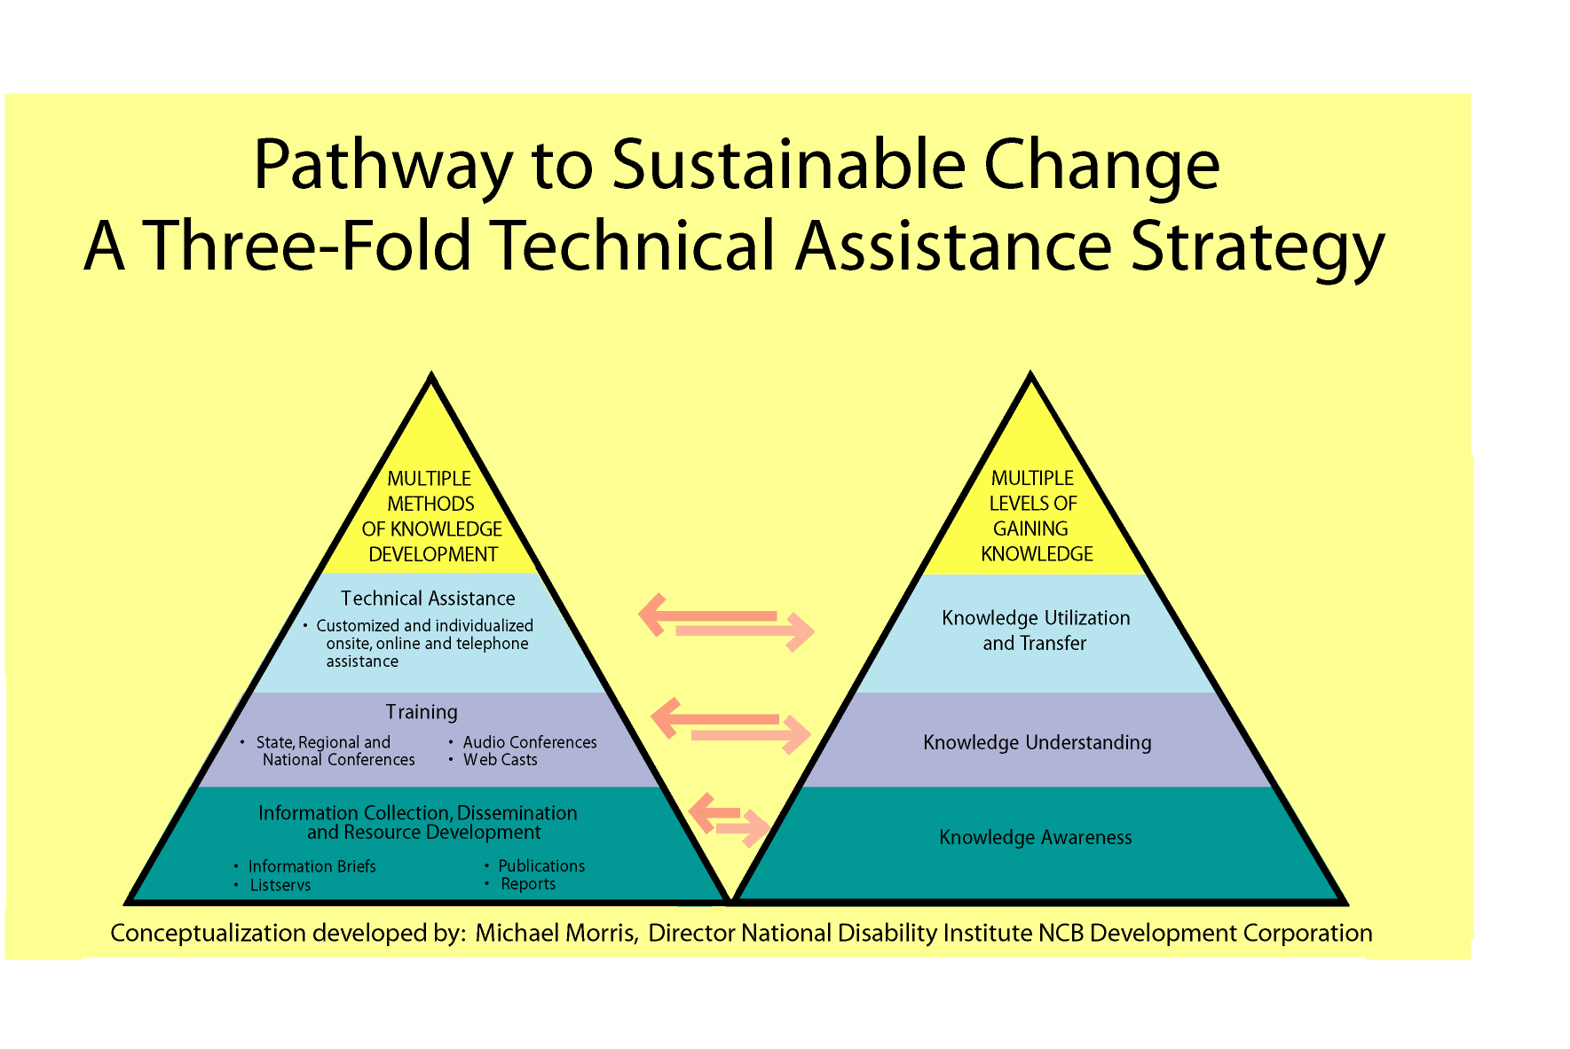

Making Medicaid Work in the 21st Century

The National Academy for State Health Policy (NASHP) issued a report recommending major changes in Medicaid to eliminate the institutional bias that drives long-term care spending. The report is based on discussions by a group of national experts that included state legislators, governors’ health policy staff, state budget officers, Medicaid and Aging Directors, advocates and researchers.
The report recommends replacing home and community-based services (HCBS) waivers with a “program option” under the Medicaid state plan and “de-linking” functional eligibility for home and community-based services from nursing facility eligibility. States would be able to set a higher threshold for admission to a nursing facility and a separate threshold for home and community-based services. The program option would eliminate the need for 1915(c) waivers, but still allow states to manage expenditures as they do through waivers. States would develop and submit a plan to the Centers for Medicare & Medicaid Services that describes the populations to be served, the number of consumers that will be served, financial and functional eligibility standards, services covered and cost sharing requirements. Once approved, the plan would not require periodic renewals.
With this plan, states would have more options to shape the delivery system. States could offer consumers one or more of the following options: an unmanaged fee for service system that does not include home and community-based services, a care managed (comprehensive entry point) fee for service system, a risk-based capitated delivery system, and an integrated acute and long term care system.
The report also recommends setting eligibility as a percentage of poverty rather than using the myriad of categorical eligibility groups. Other recommendations addressed financing, benefits, quality and dual eligibles. The full report and several issue briefs are available at www.nashp.org.
Contact Robert Mollica at rmollica@nashp.org or 207-874-6524.

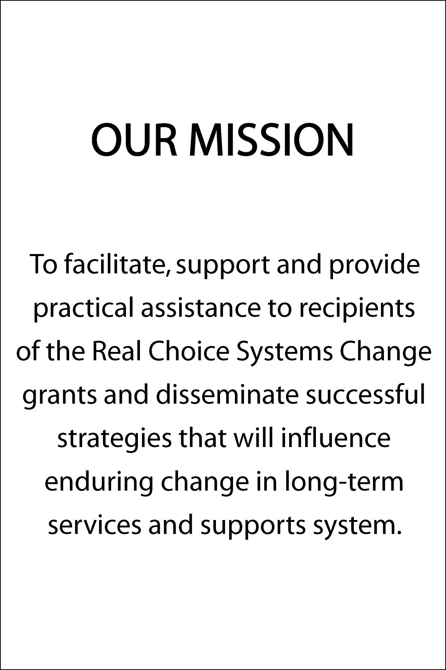



Community Living Exchange
Page 7

Rutgers CSHP/NASHP
Community Living Exchange

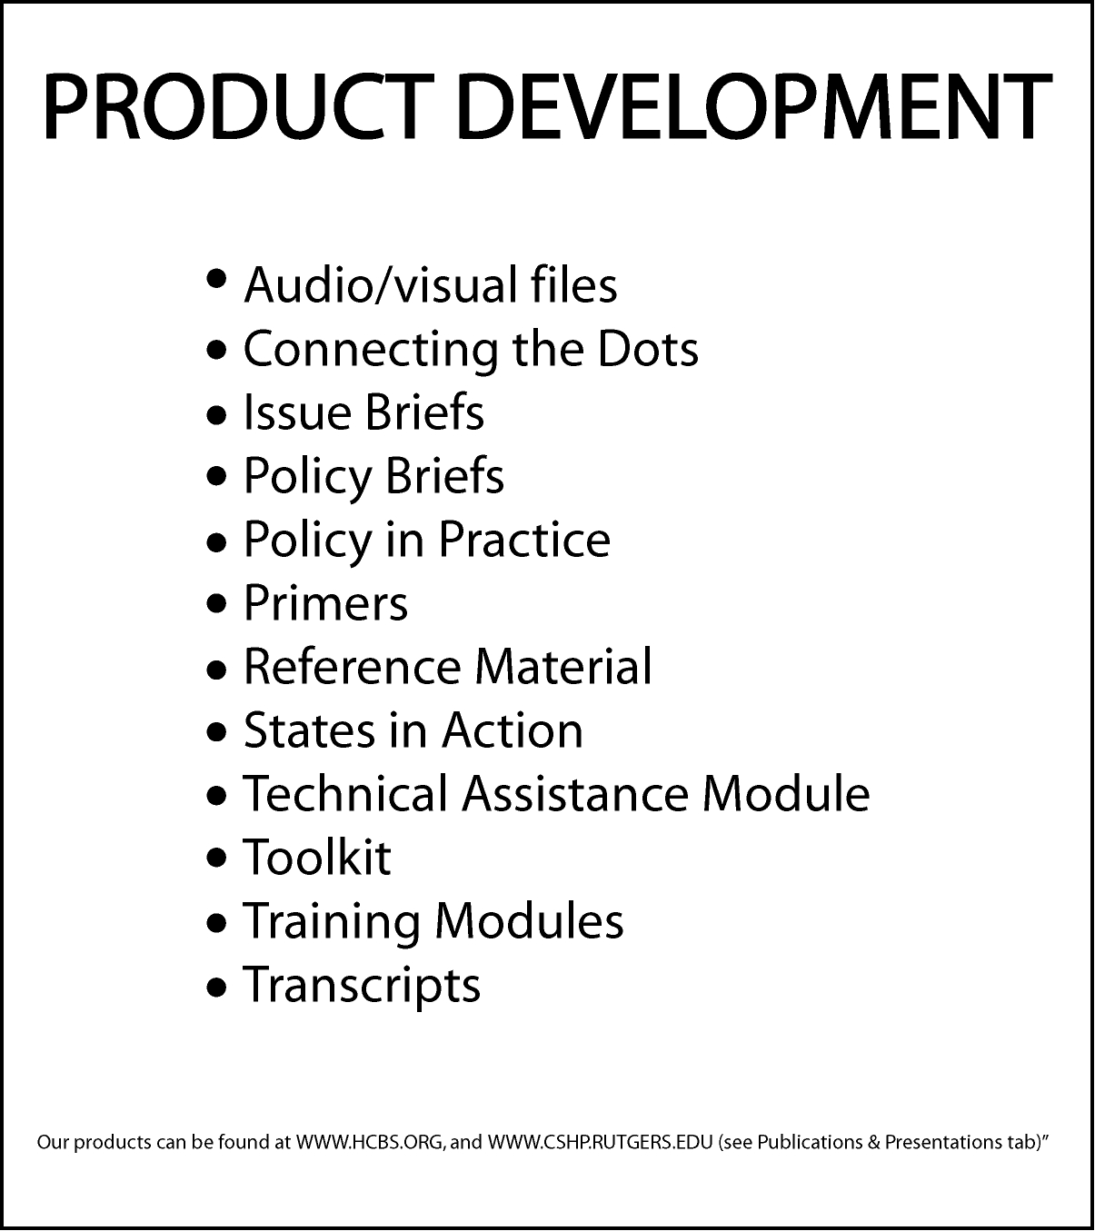
Assessment Instruments in 12 States

The Michigan Department of Community Health recently streamlined functional/medical eligibility criteria for Medicaid reimbursed long-term care services. The revised criteria, which became effective November 1, 2004, apply to all Medicaid nursing facility, MI Choice waiver and PACE services (a comprehensive description of the eligibility determination process is available at www.michigan.gov/documents/MSA-04-15_104506_7.pdf). It includes the nursing facility (NF) level of care criteria, nursing facility applicant Pre-Admission Screening, and annual NF resident review requirements. Michigan is one of the states highlighted in the Rutgers CSHP/NASHP Community Living Exchange report, Assessment Instruments in 12 States. The compilation of assessment instruments in this report is designed as a resource for states considering streamlining their instruments or processes for eligibility determination, assessment, or care planning. Included in this report are snapshots of 12 states’ assessment instruments, including an overview of the major components of the assessment instrument and its role in a state’s processes.
This review of twelve assessment instruments suggests a number of trends in instruments employed by states. Our analysis showed a tremendous variability in how these tools are incorporated into states’ HCBS activities, although the content of the questions included in assessment instruments was found to be quite similar. We found that states are moving toward integrating as many components of the eligibility determination, assessment and care planning processes as possible. Combining functional and financial eligibility is an important component of efforts to streamline access to home and community-based services, although only one-quarter of the assessment instruments reviewed incorporated financial eligibility. Half of the instruments reviewed are used for Medicaid beneficiaries seeking home and community-based services and nursing facility admission. Using the same assessment instruments for both populations has the potential to prevent nursing facility admission for people who prefer to live in a community-based setting.
Contact Jennifer Gillespie at (207) 874-6525 or jgillespie@nashp.org.
- Assessment Instruments in Twelve States, http://www.hcbs.org/moreInfo.php/nb/doc/844/

Contact us at:
commlivingexchange@ifh.rutgers.edu

Community Living Exchange
Page 8
Attendee Feedback from the CMS Conference:

“I was impressed with the focus on consumer direction and the increased involvement of consumers in the conference.”

”The breakdown of factors that hinder transitioning was very helpful in getting to the root of the problems.”

“Emergency back up…is a huge issue for people who want to age in place in so-called independent housing or live in scattered site ‘special needs’ housing. It always helps to hear what other states are doing.”

“I thought it was a wonderful event. I learned a lot…The energy of the presenters and colleagues was fabulous.”

CMS Conference: New Freedom Initiative: Building Sustainable Systems for Independence

CMS sponsored a conference for grantees of the New Freedom Initiative programs on February 28 – March 2, 2005. The conference was funded by the Rutgers CSHP/NASHP Community Living Exchange. Almost 700 grantees, consumers, advocates, technical assistance providers, federal employees, service providers and others attended and gave the conference high ratings.
The agenda from the conference, as well as copies of materials distributed by presenters is available at: http://www.nashp.org/cmsconference2005/_docdisp_page.cfm?LID=F7F3493D-56EE-4F2E-8FB66CFA0AB6BADD.
The 4th edition of the Compendium of the Real Choice Systems Change Grants was distributed at the conference. It provides basic information about each of the Real Choice Systems Change Grantees and describes how grants will be used to allow more people of all ages with a disability or long-term illness to live and participate in their communities. It is available at: http://www.hcbs.org/moreInfo.php/nb/doc/1154.

Facilitated Discussion for Nursing Facility
Transition Grantees
The NFT Facilitated Discussion and dinner was attended by 32 Nursing Facility Transition grantees on March 1st at the CMS Conference. The discussion focused on whether staff and resources for counseling on community options should be provided in the hospital versus within a short period of time after individuals reach the nursing facility. Minnesota discussed lessons learned on newly implemented long-term care consultation service that focuses on nursing facility residents who want to explore community living alternatives.

Grantees
identified the following issues around Quality Management for further research:

Model sub-state and provider contract provisions for QM roles;
Model job descriptions for QM;
Model Memorandum of Understanding for state units with overlapping QM responsibilities; and,
Standardized QM training curriculums.

Community Living Exchange
Page 9

Home and Community-Based Services: Quality Management Roles and Responsibilities
Quality Management (QM) in HCBS is the topic of study in this three-paper series that the Edmund S. Muskie School of Public Service is developing as part of its work with the Rutgers CSHP/NASHP Community Living Exchange. This first report presents current ideas and practices of states in the area of quality, and identifies areas where further research is needed to assist states in efforts to develop effective QM programs.
This Discussion Paper reports on how states conceptualize QM in HCBS. Assessing quality in HCBS is somewhat unique from evaluating quality in standard health care environments. Therefore, the CMS Quality Framework is very useful as a basis for assessing quality outcomes. Based on our findings, it appears that few states have fully organized and operationalized QM strategies, but many are developing work plans for the assessment, implementation and improvement of their waiver programs. Our paper offers a conceptual design to help states in implementing a QM strategy. The fundamental features of a QM strategy include:
- Designing HCBS programs in a way that increases the probability of quality. For example, quality is enhanced through use of trained and experienced providers, information systems that assure the timely and effective provision of care, or early warning systems for knowing when things go wrong;
- Using the process of discovery, remediation and improvement to make certain the program is working as intended;
- Synthesizing information to determine which aspects of the program should be targets for improvement, identifying actions to achieve improvement, and monitoring and evaluating the outcomes of those efforts; and
- Assuring that all administrative entities and stakeholders understand the roles that they must play in managing and promoting quality.
As an early step to creating QM strategies, many states have conducted an inventory of their current practices and data for monitoring and improving the quality of care. Detailed overviews of the practices of several states, as well as sample formats for capturing this information, are included in this report. Several emerging models are provided as reference points for states to evaluate their current status in QM and to assess how they can move to the next stage.
The Edmund S. Muskie School of Public Service’s Institute for Health Policy will continue to collaborate with the Community Living Exchange by producing two more reports in its QM series: Tools for Discovery, Remediation and Quality Improvement; and Use of Quality Indicators.
Contact Maureen Booth 207-780-4430 or at maureenb@usm.maine.edu.

- Home and Community-Based Services: Quality Management Roles and Responsibiliities, http://www.hcbs.org/moreInfo.php/nb/doc/1132/

Family Caregiving

What’s new in…
Community Living Exchange
Page 10
The lack of consensus regarding respite services may result in lack of access for potential beneficiaries, non-coordination of benefits, and underutilization of services, with the possible outcome of over-burdened caregivers relinquishing their responsibilities to governmental and institutional facilities.
From “Defining Respite,” at www.hcbs.org.

Respite at the CMS New Freedom Initiative Conference
Respite care was the focus of a pre-conference session held at the CMS New Freedom Initiative Conference. Attendees included Respite for Children and Respite for Adult grantees, CMS and Rutgers Center for State Health Policy staff. The agenda featured presentations by the Family Caregiver Alliance (FCA) and the state of Oregon. Lynn Friss Feinberg provided attendees with an overview of the results of FCA’s comprehensive 50-state study, State of the States in Family Caregiver Support. This report examines publicly funded caregiver support programs in all 50 states and the District of Columbia. It examines programs provided through the Older Americans Act’s National Family Caregiver Support Program, Aged/Disabled Medicaid waiver programs, and state-funded programs. It highlights key findings, offers state-by-state profiles, pinpoints challenges, identifies issues for the future, and expands recognition of family caregiver needs as distinct from the needs of care receivers. The information provided in the report can also be accessed through a searchable database available on the Family Caregiver Alliance website. A second presentation was given by Sara Gelser from Oregon, who provided information on successes and barriers in respite program practices. Her presentation included a discussion on Oregon’s programs for respite in nursing homes and respite for multiple children in the home.
The pre-conference also provided an opportunity for grantee information sharing in an open discussion session, where grantees talked about the cost of respite, strategies for validating respite through cost-savings evidence, and how to manage distribution of services. There was a strong interest in initiating further study on development of caregiver assessment tools and issues around workforce for respite. These and other topics will be examined in future activities by the Rutgers CSHP/NASHP Community Living Exchange. The Community Living Exchange plans to facilitate future conference calls on caregiver assessment, an examination of the service model used by Ohio, and development of a wish list for future demonstrations.
Also at this session, Rutgers distributed its Discussion Paper, Defining Respite Care. This technical assistance document was prepared to generate dialogue about respite care that encompasses outcome-based services and progressive policy analysis. The goal of this paper was to determine, through examination of federal documents and published literature, whether a common definition of respite can be applied in HCBS waiver applications. The analysis found a diverse range of definitions of respite in the documents reviewed, and identified the primary goal of respite to be the rejuvenation, relief and strengthening of the caregiver network. Therefore, a policy shift towards family versus individual outcomes is recommended for examination in follow-up studies.
Contact Susan Reinhard at 732-932-3105 or sreinhard@ifh.rutgers.edu.
- State of the States in Family Caregiver Support, http://www.caregiver.org
- Defining Respite Care, http://www.hcbs.org/moreInfo.php/nb/doc/1171/

The top barriers
to coordinating caregiver support programs with other HCBS programs in the states are differing eligibility requirements and service complexity and fragmentation.
From “The State of the States in Family Caregiver Support,” at www.caregiver.org.

The Massachusetts Supportive Housing Program (SHP) saves $3,205 in federal and state spending ($1,287 in net state savings) for every month that a nursing home placement is avoided.
Community Living Exchange
Page 11

What’s new in…

Housing

Massachusetts Supportive Housing Program (SHP)
According to the publication Aging in Place: Coordinating Housing and Health Care Provision for America’s Growing Elderly Population (http://www.jchs.harvard.edu/publications/seniors/lawler_w01-13.pdf), in the last decade it has been recognized that older persons do not necessarily need to relocate as their needs change, but instead their environment can be modified to meet their needs through provision of accessible supportive services and reconfiguration of their residence. Aging in place has not only become the most desirable way of aging but also, in most cases, it is the more cost-efficient way of aging, because it minimizes the provision of inappropriate care, offers a range of flexible services and calibrates those services to fit the needs of the individual. To develop an efficient method of service delivery, the long-term care system needs to reflect a strong relationship between health and housing.
The Massachusetts Supportive Housing Program (SHP) report, written by Robert Mollica and Michael Morris, describes a Massachusetts program that was developed in 1999 to strengthen coordination between housing and service agencies for the purpose of providing support for aging in place by creating an assisted living like environment in state funded, public elderly housing. The SHP has been shown to improve the efficiency of in-home services and to expand the range of services available. The Supportive Housing Program requires a partnership between the local housing authorities, the Aging Services Access Points (ASAP) that serve as the state’s single entry point agencies for HCBS, and a local service provider. The ASAP agrees to assign a service coordinator to the building and also meets regularly with the local housing authority to discuss marketing and tenant issues. The ASAP also selects a service vendor that agrees to assign staff to the building and to provide 24-hour coverage. Key informants for this study identified the on-site presence of the service coordinator, and the availability of supports for emergency and unscheduled needs on a continual basis as the most important contributors to the success of the program. Massachusetts uses state funds to support the program, but states considering this model that do not have access to state funds could reimburse covered services under a 1915(c) waiver for tenants that meet the waiver level of care criteria. Federal reimbursement may also be available for activities relating to Medicaid beneficiaries that do not meet the waiver criteria.
Contact Robert Mollica at 207-874-6524 or rmollica@nashp.org; Michael Morris at 202 521-2930 or mmorris@ncbdc.org.
- Massachusetts Supportive Housing Program, http://www.hcbs.org/moreInfo.php/nb/doc/1178/

Housing and Services Theme Page Launched on HCBS.org Website
In December 2004, the Housing Coordinated with Services theme page was launched on the HCBS website. This resource provides information for individuals and grantees interested in topics related to housing and services. The page provides a wealth of up-to-date information to grantees on current polices and promising practices to assist in successful expansion of community-based living opportunities for persons with disabilities.
From the HCBS home page, users can click on “Theme Pages” and enter the newly created page. The page provides various information sections including, “What’s New,” FAQs and Highlighted Articles. The What’s New section’s goal is to keep grantees and individuals aware of new publications, policy developments at federal, state and local levels, funding opportunities and recent fair housing developments that offer alternative approaches to expand affordable, accessible and integrated housing choices for individuals with disabilities. The FAQs section provides answers to questions on various topics including accessibility, community plans, funding, and housing and services coordination. Grantees can also access contact information on technical assistance providers for the Real Choice Systems Change grants.
Located on the left navigational bar, the Highlighted Articles provide information on case studies of promising practices and “Tools You Can Use” for grantees. For any grantee that has been unable to participate in the Essentials of Housing or Advanced Strategies subgroups monthly conference calls, the summary notes are located in this section. Grantees are encouraged to visit often and utilize the “Browse All Housing Articles” link on the lower left hand corner for more information.
The Housing Coordinated with Services page is an ever-changing site that provides grantees with updated information and tools to assist in the implementation of strategies to expand housing choice for individuals with disabilities.
Contact Michael Morris at 202 521-2930 or mmorris@ncbdc.org.

- Clearinghouse for the Community Living Exchange Collaborative, http://www.hcbs.org.

The Massachusetts SHP has resulted in reductions in vacancy rates, higher demand leading to waiting lists for once less desirable rental units, and substantial reductions in nursing home admissions, hospital admissions and unexpected resident deaths.

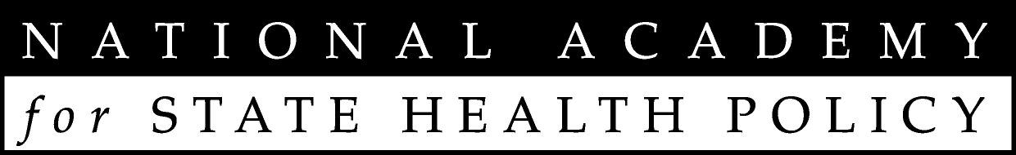
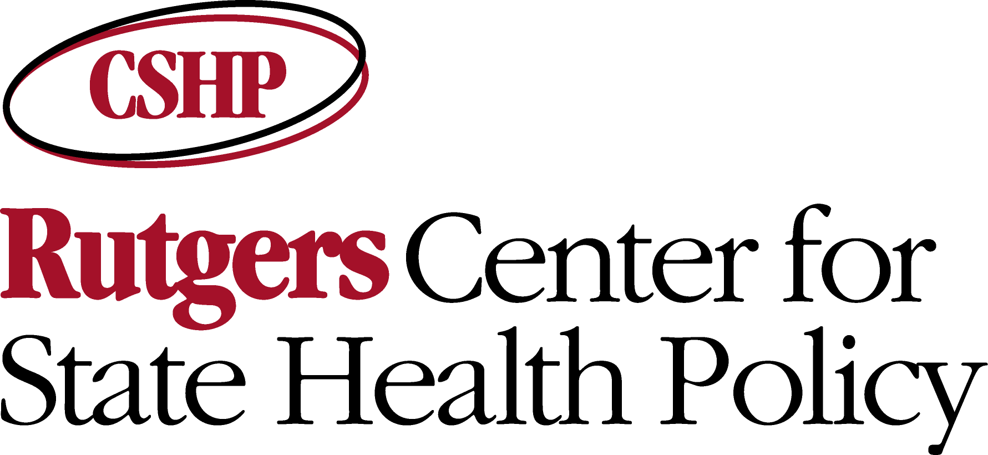
Community Living Exchange
317 George Street
Suite 400
New Brunswick, NJ
08901-2008

Phone:
(732) 932-3150

Fax:
(732) 932-0069

E-Mail:
commlivingexchange@
ifh.rutgers.edu
Community Living Exchange
Page 12

If you have any ideas for group or individual technical assistance, please contact us at commlivingexchange@ifh.rutgers.edu with your suggestion or request.
Requests

