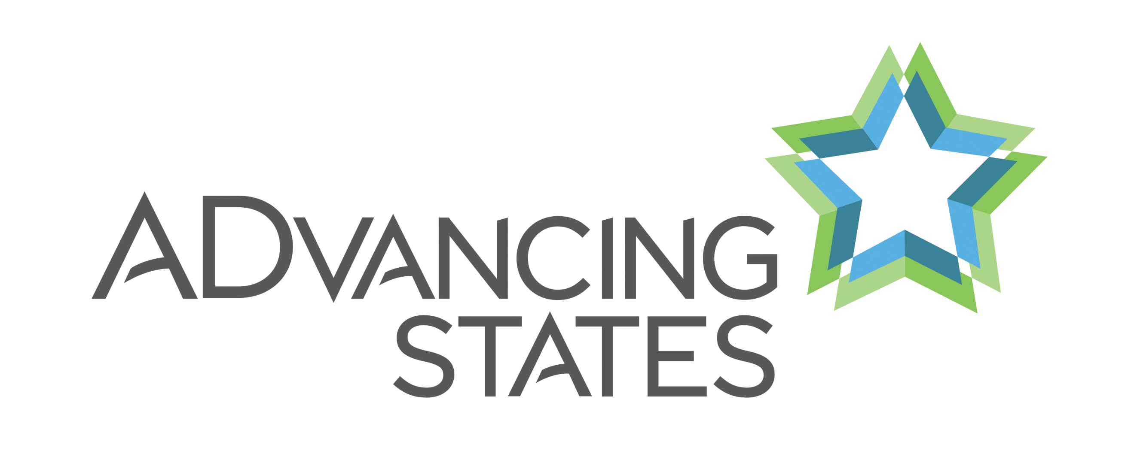

ADvancing States

Caregiving Policy Associate
Full Time

ADvancing States represents the nation’s 56 state and territorial agencies on aging and disabilities and supports visionary state leadership, the advancement of state systems innovation, and the articulation of national policies that support home and community-based services for older adults and individuals with disabilities.

ADvancing States is seeking a Caregiving Policy Associate. The policy associate will collaborate with senior Association leadership in providing technical assistance, training, and policy support to the nation’s leaders in caregiving and direct care workforce issues. The successful candidate will be a college graduate with at least 3-5 years’ experience in either aging services, long term services and supports, home and community-based services, or a related field. The candidate should have strong leadership skills; demonstrated written and oral communication skills; and possess analytical capability.

This position is full-time and based in Arlington, Virginia. Remote work may be available.

Key Responsibilities
- Research: use reputable survey data systems; compile, track and maintain qualitative data; analyze.
- Project Management: maintain and track ADvancing States Caregiving team projects to ensure quality and timely implementation of deliverables.
- Communications: support and sustain ADvancing States Caregiving team relationships with aging and disability network national partners, including responding to ad hoc requests from state agencies.
- Development: collaborate in developing templates and tools for state direct care workforce advisory boards/committees; research and post resources for aging and disability state members.

Basic Qualifications
- Master’s or bachelor’s degree; public policy, health policy, public administration, social work, or related field preferred.
- Ability to be flexible, multi-task, prioritize, and manage multiple partners.
- Strong verbal, written and interpersonal communication skills.
- Excellent organizational skills and attention to detail.
- Strong analytical, problem-solving, and decision-making capabilities.
- Ability to work independently and take initiative.

To apply, please send a resume and cover letter to: HR@advancingstates.org. ADvancing States is committed to providing equal opportunities for all applicants for employment and strongly encourages individuals with disabilities to apply. We are an Equal Opportunities Employer.

