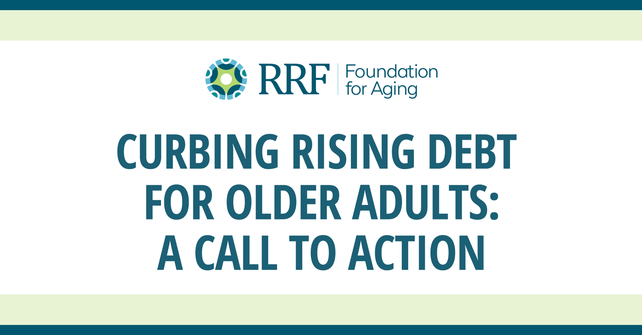

**Digital Sharing Kit for RRF Foundation for Aging’s Curbing Rising Debt for Older Adults: A Call to Action**

We are pleased to introduce RRF Foundation for Aging’s [Call to Action](https://www.rrf.org/wp-content/uploads/220913-FINAL-RRF-CTA-DEBT-SOLUTIONS-V3.pdf) on addressing debt burden for older adults. In alignment with one of its key priority areas, Economic Security in Later Life, RRF’s Call to Action invites others to partner with the foundation to develop new ways to prevent, manage, and mitigate debt among older adults.

Contrary to common perceptions and despite efforts to save for retirement, millions of older adults hold high-risk debt, and the numbers and level of debt are growing. The pernicious consequences of debt threaten to further undermine the already fragile financial security of many older people. In fact, the share of older people who have incurred “high risk” debt—credit cards, medical bills, and student loans—has soared 50 percent in two decades. The current economy, and a pandemic that accelerated the drain on retirement accounts, is making matters worse.

RRF Foundation for Aging calls upon advocates, researchers, service providers and others to get involved in addressing this urgent issue.

***

This digital sharing kit contains sample social media posts, website and newsletter language, and graphics that you are welcome to use or adapt to suit your organization. Please feel free to share it with colleagues, grantees, or anyone else interested in reducing debt among older adults.

If you have any questions, please contact RRF at [info@rrf.org](mailto:info@rrf.org).

**Sample Language for Your Newsletter, Blog, Website, LinkedIn, Facebook**

**RRF Foundation for Aging Releases Call to Action to Address Older Adult Debt Burden**

In a new Call to Action, RRF Foundation for Aging illuminates a problem hidden for too long – older adult debt – and calls on advocates, researchers, service providers, funders and others to get involved with addressing this urgent issue.

Contrary to common perceptions and despite efforts to save for retirement, millions of older adults hold high-risk debt, and the numbers and level of debt are growing. The pernicious consequences of debt threaten to further undermine the already fragile financial security of many older people. In fact, the share of older people who have incurred “high risk” debt—credit cards, medical bills, and student loans—has soared 50 percent in two decades. The current economy, and a pandemic that accelerated the drain on retirement accounts, is making matters worse.

This Call to Action invites others to partner with the foundation to develop new ways to prevent, manage, and mitigate debt among older adults. Read the [Call to Action](https://www.rrf.org/wp-content/uploads/220913-FINAL-RRF-CTA-DEBT-SOLUTIONS-V3.pdf) and learn more.

[**Image: Call to Action Cover Graphic**](https://app.box.com/s/6ywdqnx0crzit6fqi40ktv4xd0dhcrgf)

**Sample Twitter Posts**

**Tweet #1**

Inflation. Student loans. Volatile markets. There’s no better time to address the challenges of debt affecting older adults. @RRFAging highlights some startling statistics – and invites partners to help address them: https://bit.ly/3CvBekF #aging #funders #philanthropy

[**Image: Call to Action Cover Graphic**](https://app.box.com/s/6ywdqnx0crzit6fqi40ktv4xd0dhcrgf)

**Tweet #2**

Got an idea to address debt burden in later life? @RRFAging wants to hear from you! Curbing Rising Debt for Older Adults from @RRFAging highlights the challenges of debt for older adults and calls for action. https://bit.ly/3CvBekF #aging #funders #philanthropy

[**Image: Spiral Graphic**](https://app.box.com/s/fdytmmf79vxlex7jx2eiyh7bwyxlm7jn)

**Tweet #3**

Debt affects all families, esp those headed by people of color, immigrants & LGBTQ+ people, putting them at more financial risk later in life. In a new Call to Action @RRFAging invites partners to help prevent & mitigate older adult debt: https://bit.ly/3CvBekF #aging #funders

[**Image: Spiral Graphic**](https://app.box.com/s/fdytmmf79vxlex7jx2eiyh7bwyxlm7jn)

**Tweet #4**

Newly released Census data shows older people are the only age group getting poorer—and debt is a big factor. Check out @RRFAging’s new Call to Action to address older adult debt and share your innovative ideas: https://bit.ly/3CvBekF #aging #funders #philanthropy

[**Image: Call to Action Cover Graphic**](https://app.box.com/s/6ywdqnx0crzit6fqi40ktv4xd0dhcrgf)

